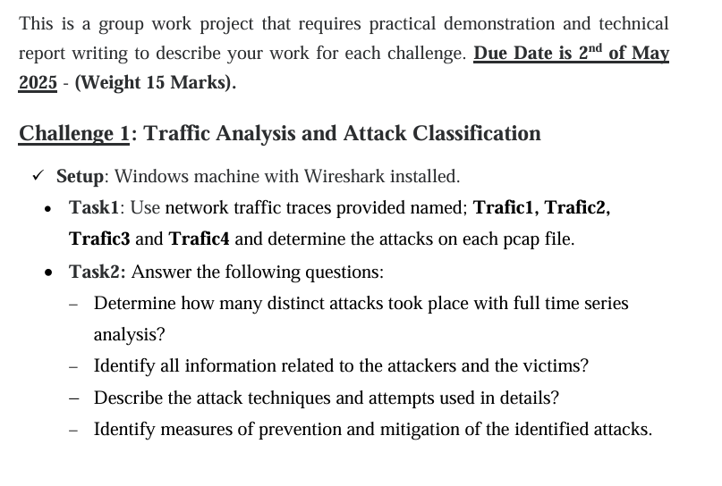
Traffic 1:
- Open the pcap file Traffic1 in wireshark
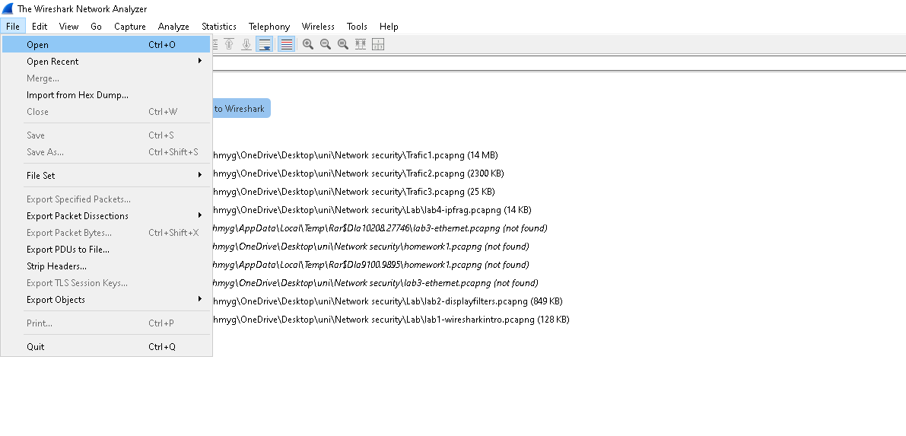

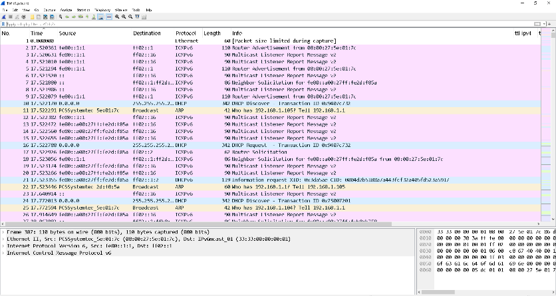
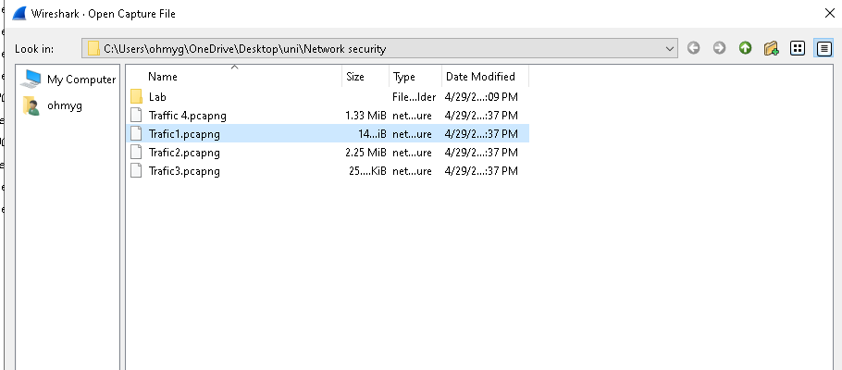

- Get overview of the traffic
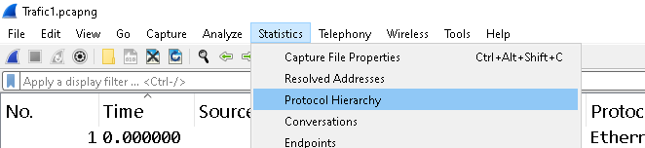

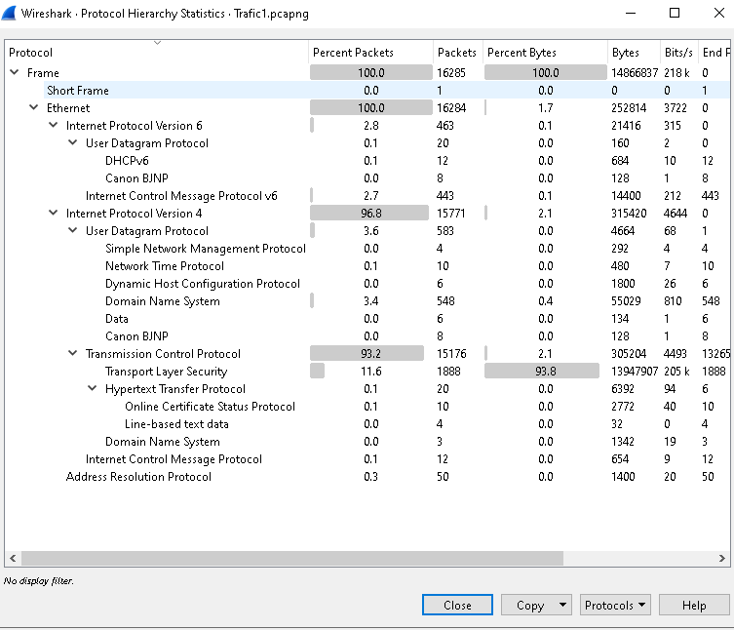

As we can see the number of packets 16285

Some Key Observations:

- TCP: 93.2 % of packets are TCP.
- HTTP: 0.1% of packets are HTTP ,suggesting significant web traffic.
- ICMPv6: 2.8 % of packets are ICMPv6, which is typical for IPv6 networks but worth investigating further.
- IPV4 : 96.8% of packets are IPV4, and only 2.8% IPV6.
- ARP : 0.3% of packets are ARP, which is normal for IPV4.

About TCP:
- The high percentage of TCP packets that mean most of the traffic is an Application-layer communication.

- The High percentage of TCP packets could be normal involve a high application-layer communication (web browsing ,file Transfer ) .

- It else could indicate:
  - A DDos Attack
  - Malware communication
  - Or normal traffic

About ICMPv6 :
- ICMPv6 is used for network diagnostics and error reporting in IPv6 networks .
- It could be : ICMP Flood : DDos Attacks using ICMPv6 packets or Reconnaissance.

- Determine how many distinct attacks took place with full time series analysis?:
Starting by tcp filter searching unusual source/destination Ips.
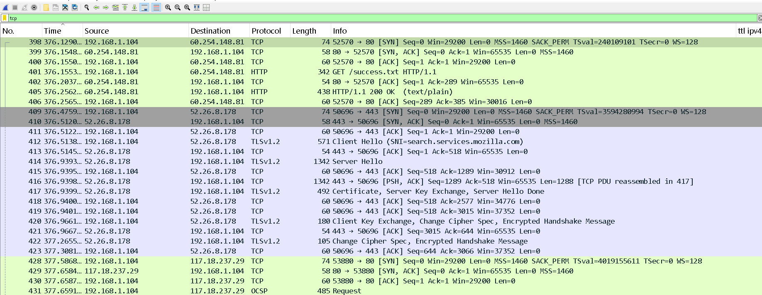

To check if it’s a SYN Flooding
We apply this Filter

tcp.flags.syn == 1 && tcp.flags.ack == 0

So this filter captures only the first SYN packet sent by the client to initiate a TCP connection, and without ACK.

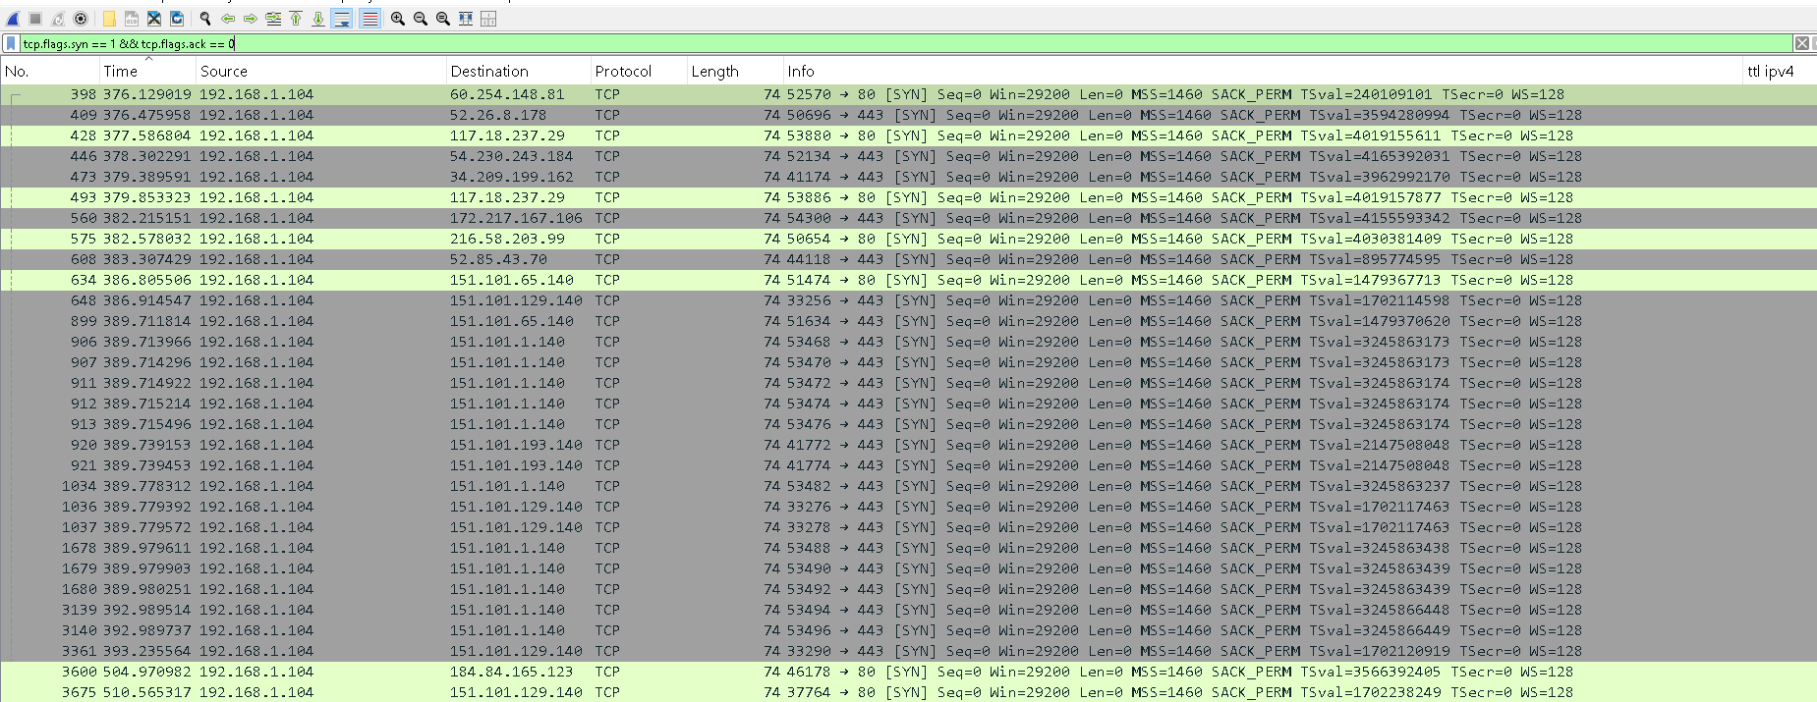

As we can see packets with only SYN set possible DoS attempt.

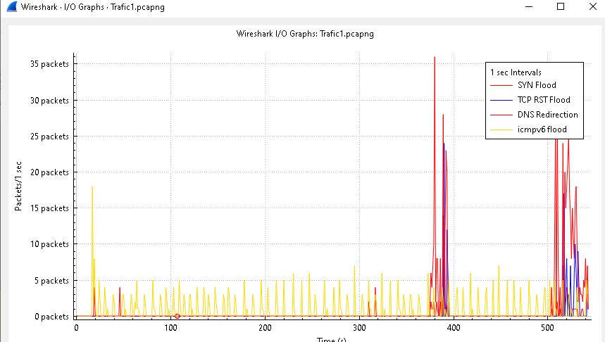

Check the ICMPv6 by using filter icmpv6, To investigate whether there are any unusual ICMPv6 packets, such as ping sweeps or floods.

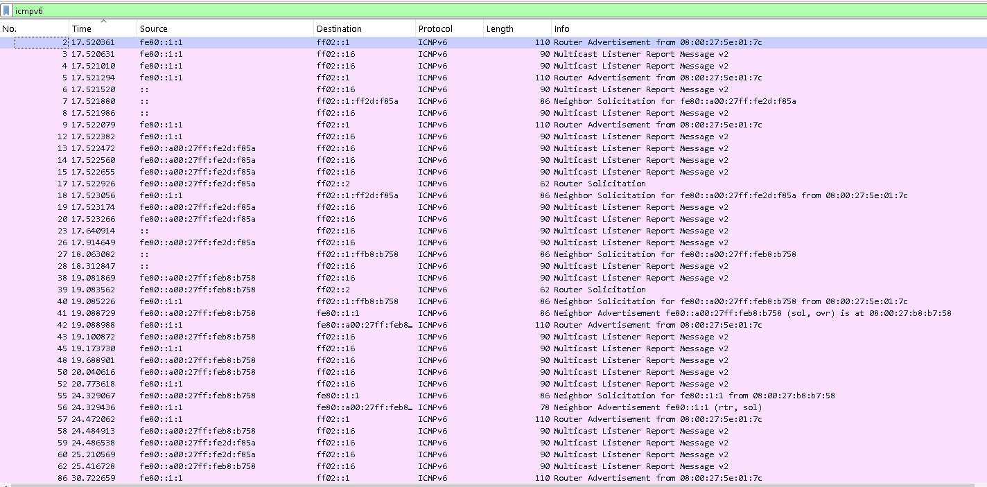

The attack occurred between 376 seconds and 392 seconds into the capture. It involved a SYN Flood DDoS attack from an internal targeting multiple external IPs over a short duration (16 seconds).
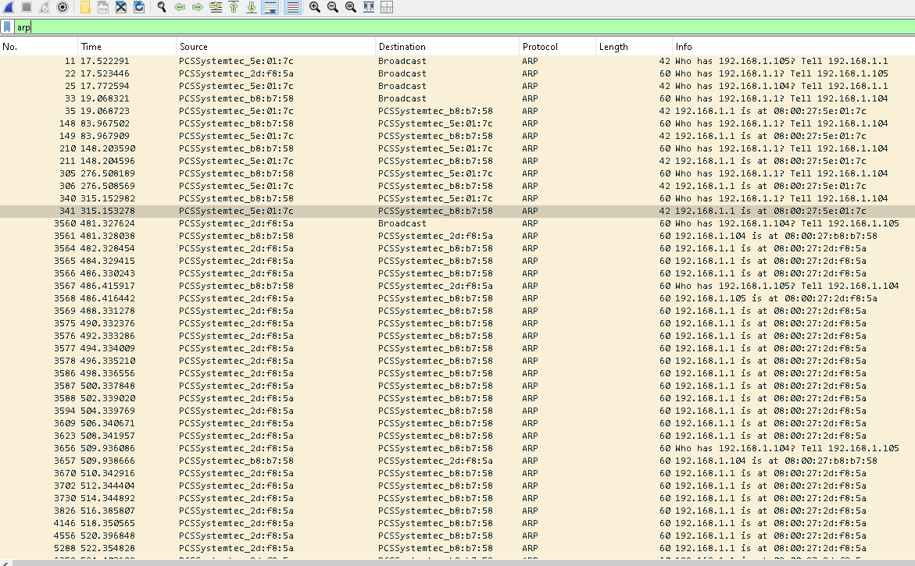

TCP SYN Flood Attack
time in around a (~16 sec),why because the high volume of TCP SYN packets without completing the handshakes, followed by number of packets of RST,ACK response rejection

ARP spoofing / Man-in-the-Middle (MITM) Attack
A single MAC address (08:00:27:2d:f8:5a) is mapping itself to multiple IPs including the default gateway.

ICMPv6 Flood cause the high volume of packets in the same sec

- Identify all information related to the attackers and the victims?

Spoofed IP Addresses:
- 192.168.1.1 (Default Gateway)
- 192.168.1.105
Attacker:
- IP: 192.168.1.104
victims:
- IP: 60.254.148.81, 117.18.237.29

- Identify measures of prevention and mitigation of the identified attacks?

- SYN Cookies: SYN cookies are a technique used to handle SYN requests without storing state information on the server until the client completes the TCP handshake. This prevents the server from being overwhelmed by half-open connections.

- TCP Intercept: TCP intercept is a feature that can be enabled on routers or firewalls to intercept and validate incoming SYN requests before they reach the server.

- Intrusion Detection and Prevention Systems (IDS/IPS): Deploy IDS/IPS to monitor and detect SYN flood attacks and take appropriate actions, such as blocking the attacking IP addresses.

For Traffic2 :
- Open the pcap file Traffic1 in wireshark

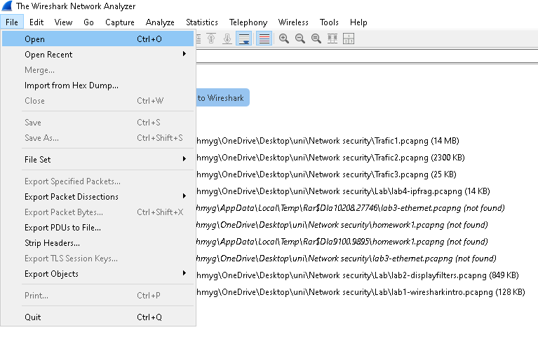
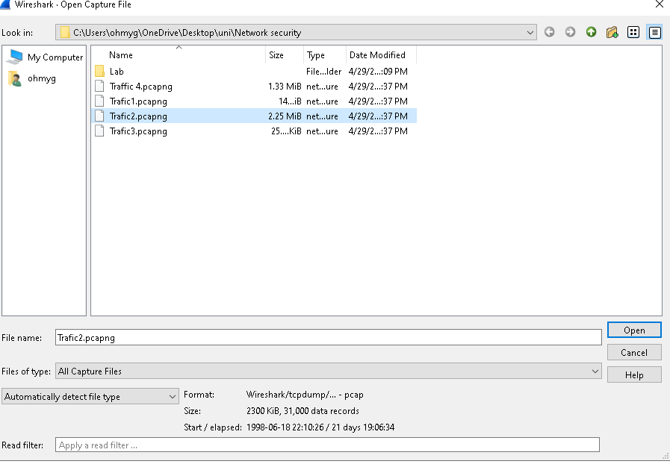
- Get overview of the traffic
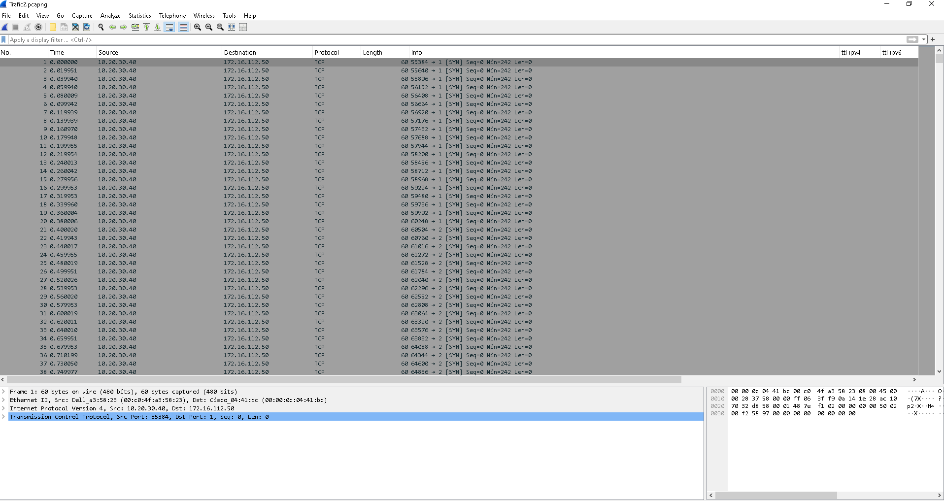
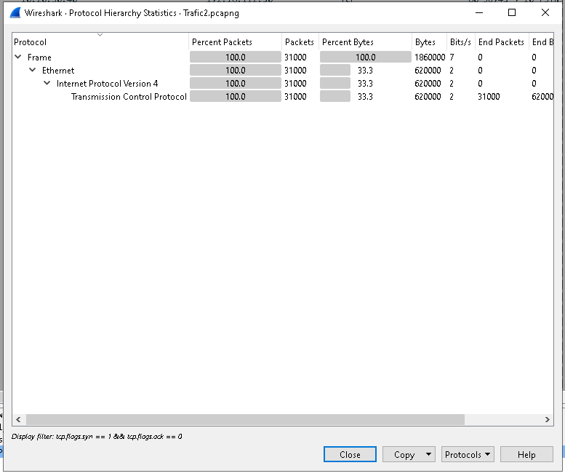
As we can see the TCP packets has percent of 100% ,this a sign of DDos attack .
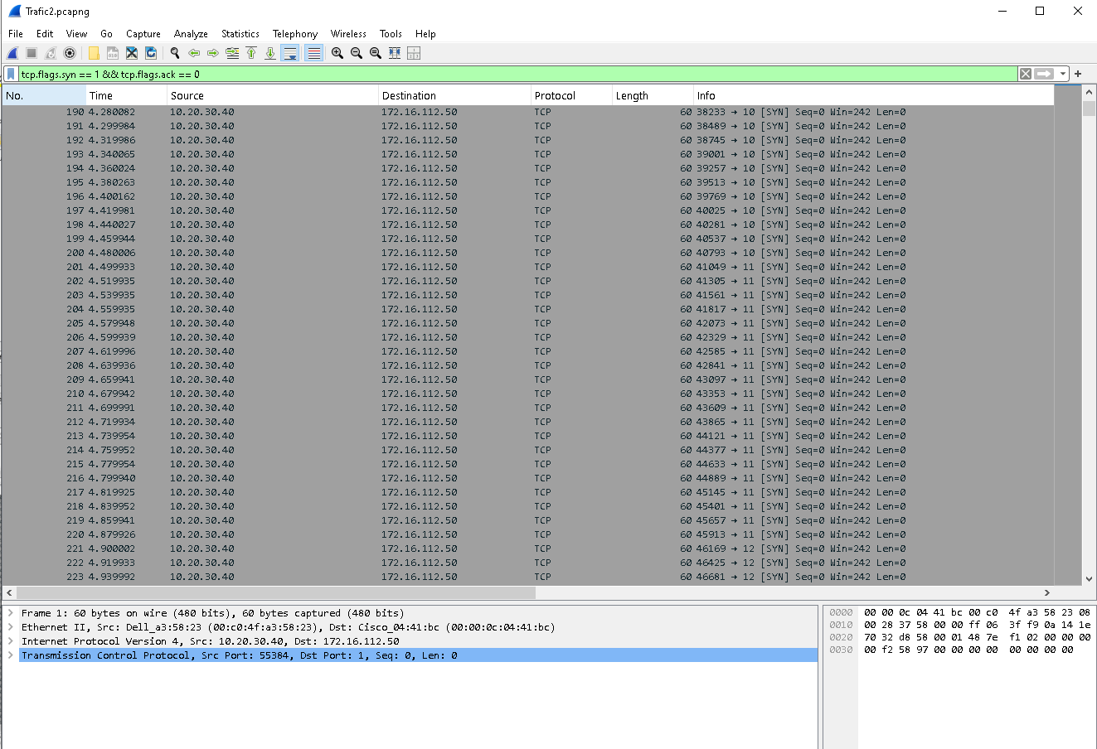
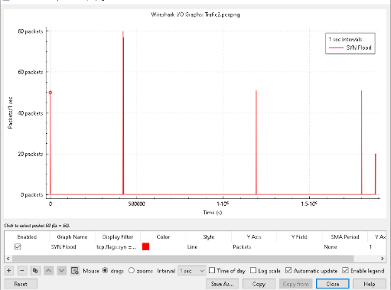
tcp.flags.syn == 1 && tcp.flags.ack == 0
ip.src == 9.9.9.9 && tcp.flags.syn == 1 && tcp.flags.ack == 0
ip.src == 10.20.30.40 && tcp.flags.syn == 1 && tcp.flags.ack == 0
ip.src == 230.1.10.20 && tcp.flags.syn == 1 && tcp.flags.ack == 0

So this filter captures only the first SYN packet sent by the client to initiate a TCP connection, and without ACK.
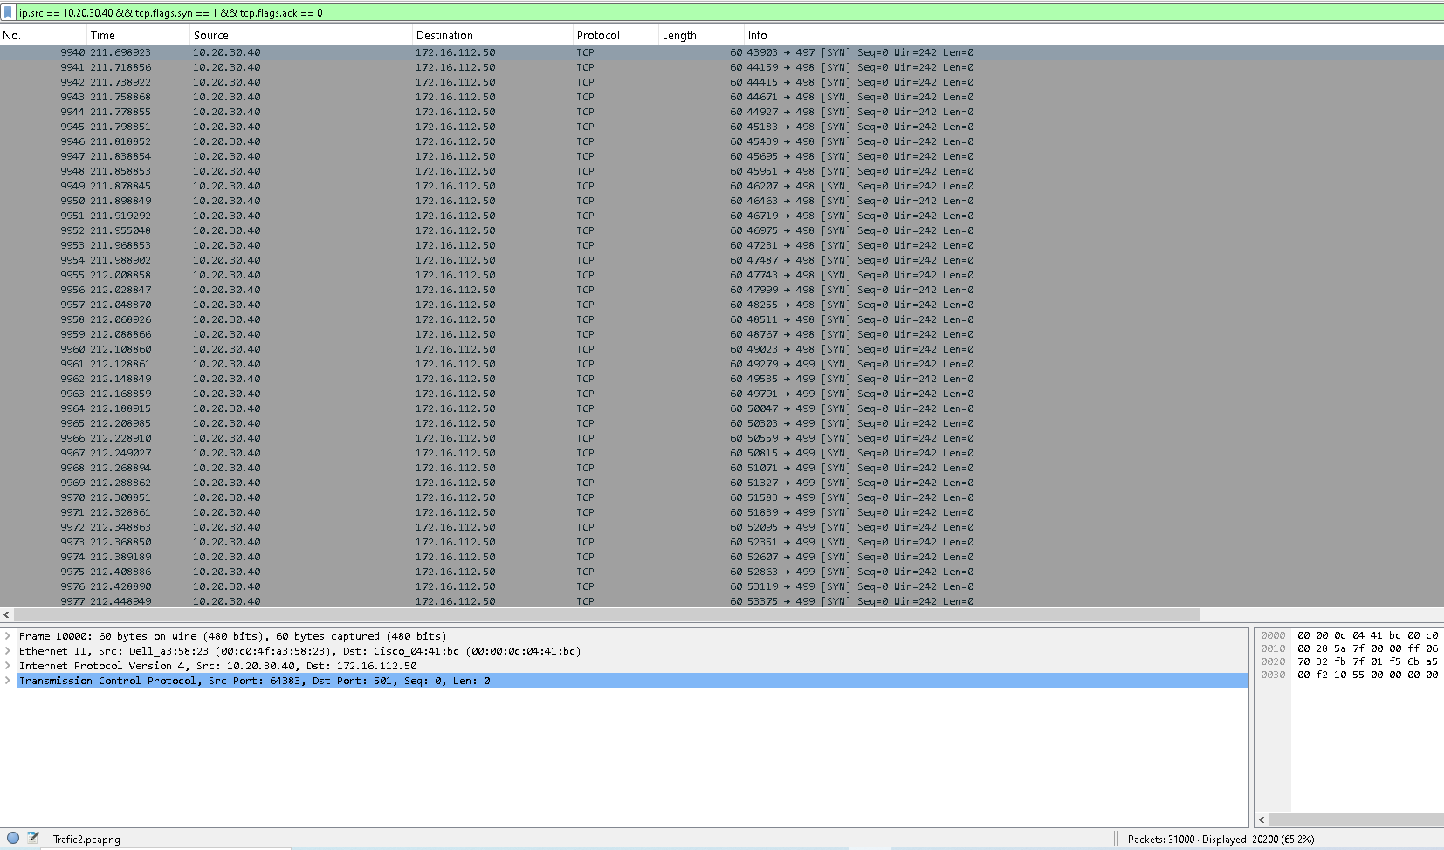

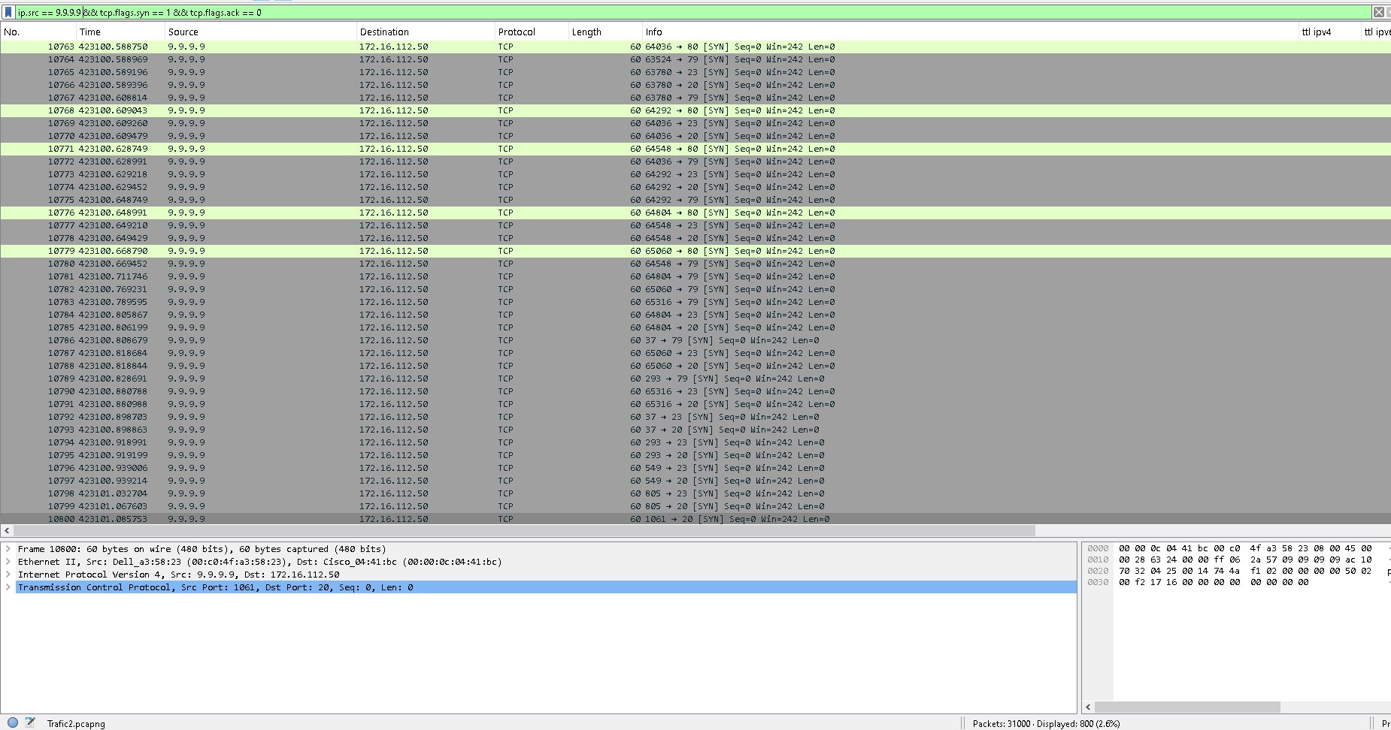
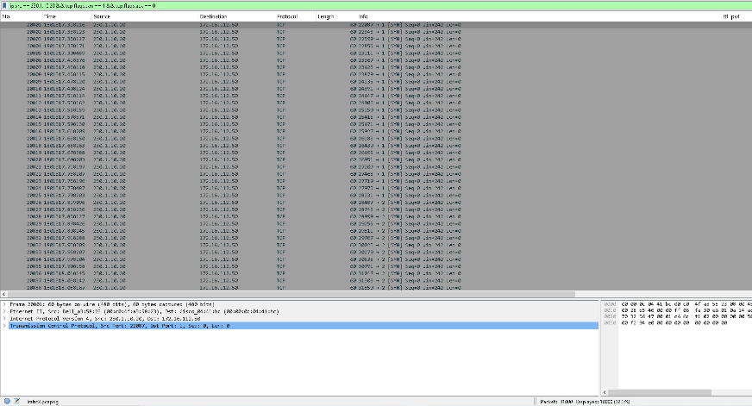

3- Determine how many distinct attacks took place with full time series analysis?

- Identify all information related to the attackers and the victims?
- Describe the attack techniques and attempts used in details?
Attack is SYN Flood DDos Attack involved multiple soirce Ips 10.20.30.40 , 230.1.10.20 sent a high SYN requests to 172.16.112.50 without completing the TCP handshake ,9.9.9.9 is being used as a spoofed source IP , it means attackers are pretending to be Quad9 (DNS resolver) while launching the attack to the same target 172.16.112.50 and to check there is no DNS packets .

- Identify measures of prevention and mitigation of the identified attacks?

- SYN Cookies: SYN cookies are a technique used to handle SYN requests without storing state information on the server until the client completes the TCP handshake. This prevents the server from being overwhelmed by half-open connections.

- TCP Intercept: TCP intercept is a feature that can be enabled on routers or firewalls to intercept and validate incoming SYN requests before they reach the server.

- Intrusion Detection and Prevention Systems (IDS/IPS): Deploy IDS/IPS to monitor and detect SYN flood attacks and take appropriate actions, such as blocking the attacking IP addresses.

For Traffic 3:
- Open wireshark
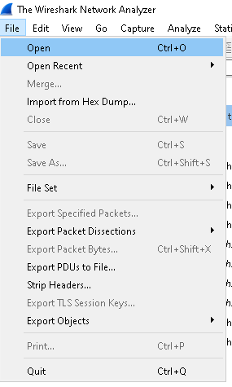
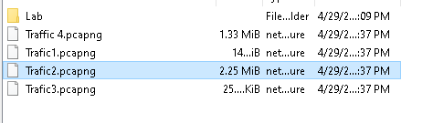

- Overview :
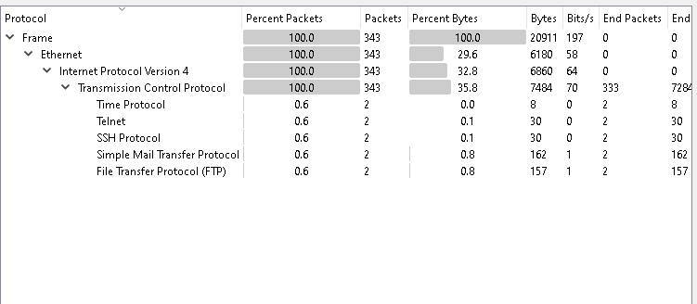
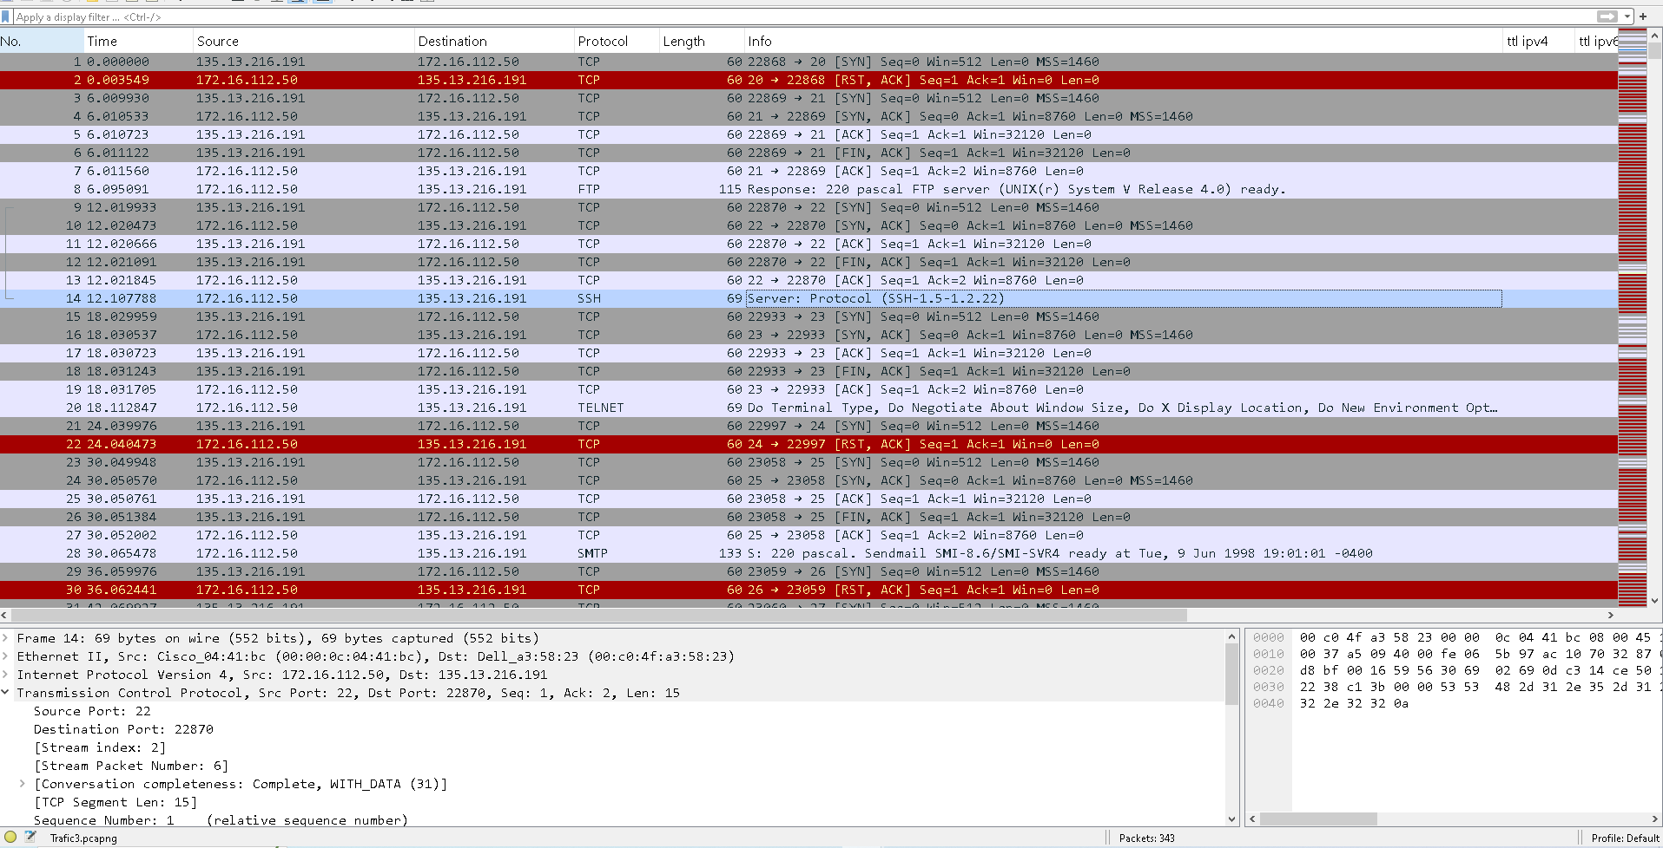

3-Determine how many distinct attacks took place with full time series analysis?

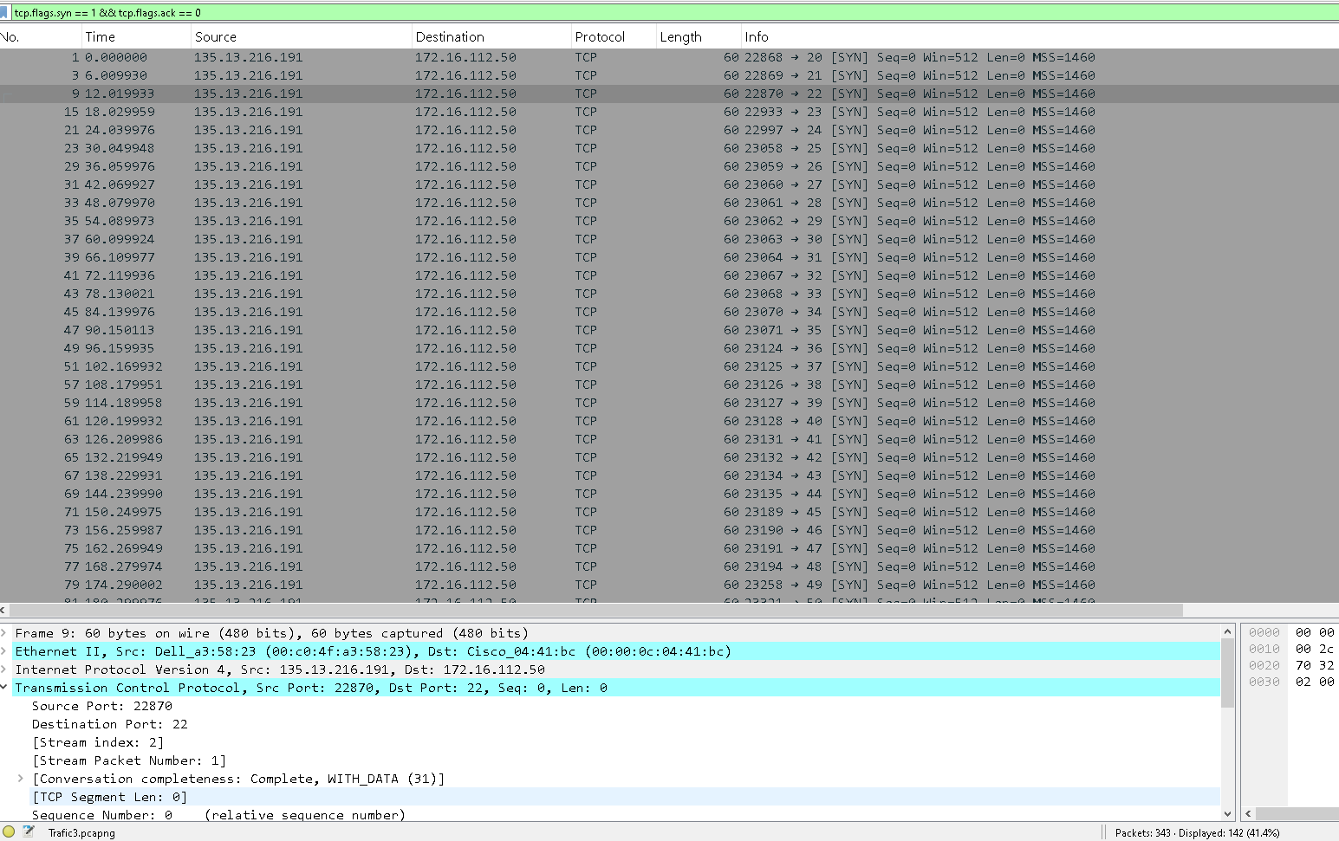
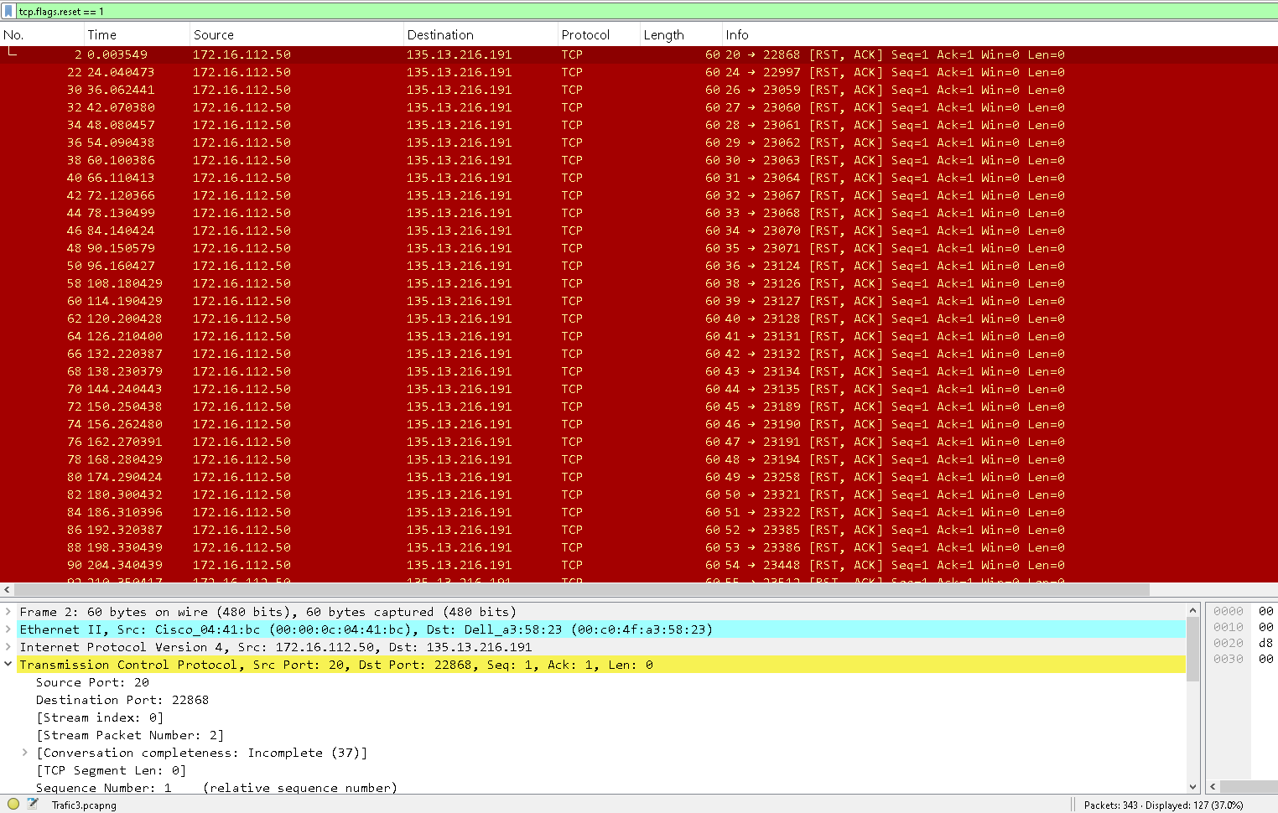
One distinct Attack was a TCP SYN port scanning Attack
Because 142 out of 343 packets were SYN packets without ACK
RST(Reset)127 [RST,ACK] responses indicating closed port, Destination ports were scanned sequentially from port 20 to port 90 (for tcp.flags.syn == 1 && tcp.flags.ack == 0 filter )
- The syn packets sent from source IP 135.13.216.191 to destination ip 172.16.112.50 targeting multi ports in seq.
- The RST-ACK response received from the destination for more attempted connections, which suggest that porsts are closed
The time difference between the packets .
- Small time differences as (0.003549 sec ) may indicate a single attack type .
- Lager consistent delays as (6 sec ) after RST-ACK.

4- Identify all information related to the attackers and the victims?
Attacks: 135.13.216.191
- Sent multiple TCP SYN packets.
- Targeted a wide range of destination ports in sequence.

Victim: 172.16.112.50
- Responded to SYN packets with RST-ACKs, indicating closed ports.

5-Identify measures of prevention and mitigation of the identified attacks:
- Firewall Rules: Block IP addresses showing scanning behavior.
- Disable Unused Services
- Rate Limiting: Limit connections per second to sensitive ports.
- Use IDS/IPS: Tools like Snort or Suricata to detect SYN scan patterns.
- Service Hardening: Run services like SSH on non-default ports.
Mitigation Steps:
- Review logs for failed connection attempts across multiple ports.
- Isolate affected systems or networks temporarily.
- Investigate the origin IP and block or report accordingly.

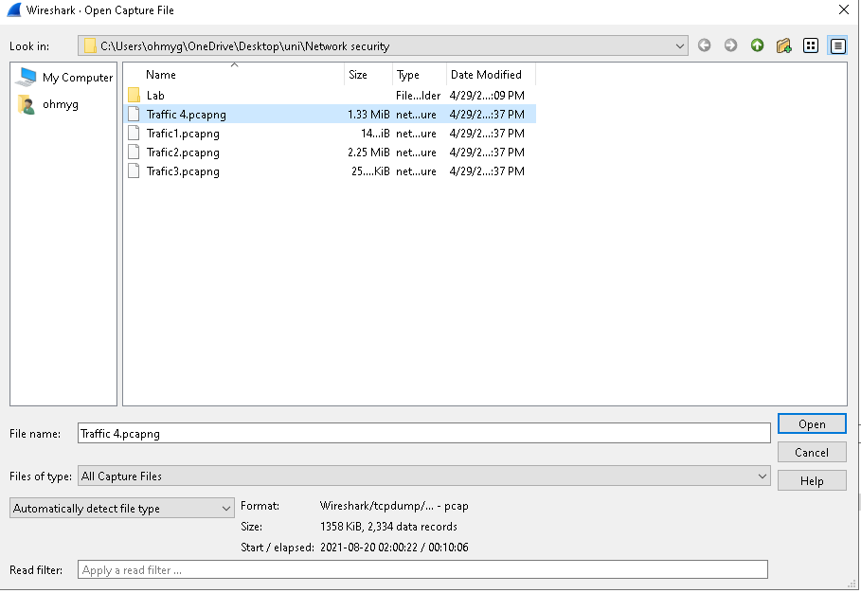
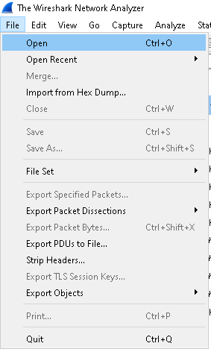
For Traffic4:
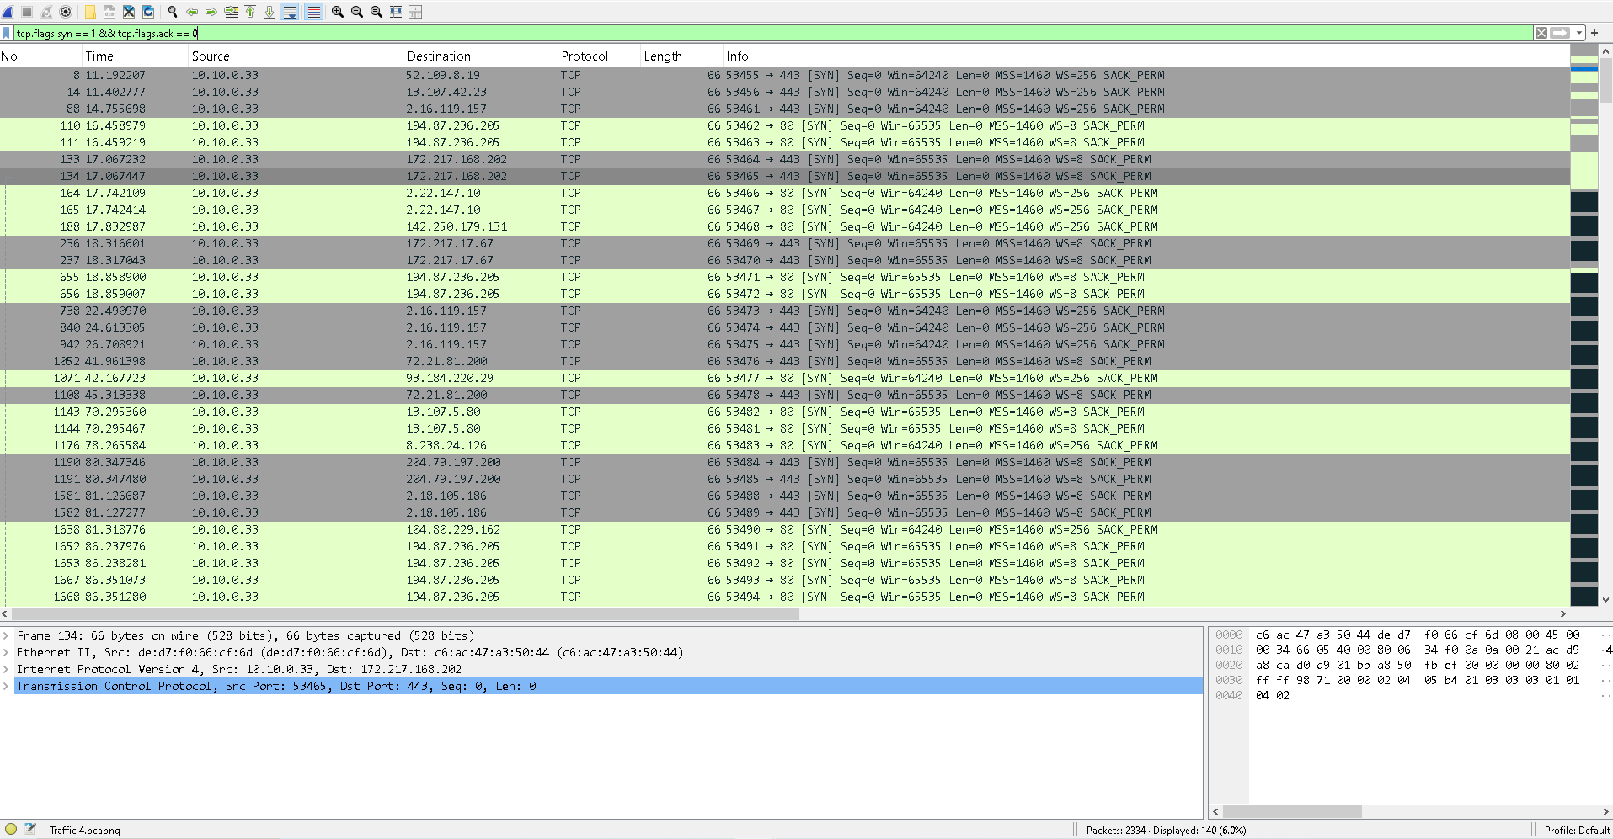
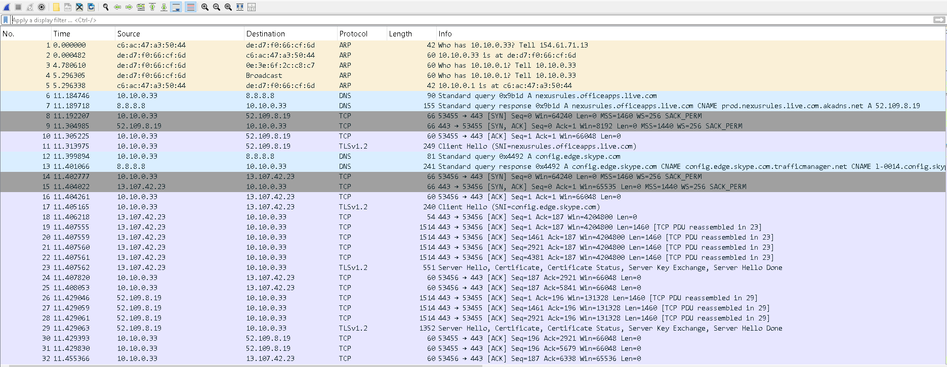

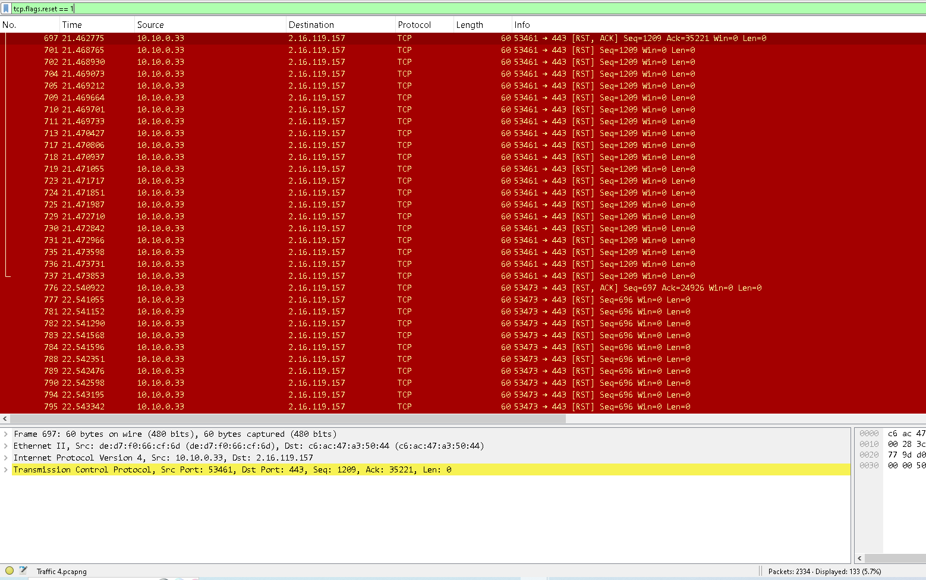
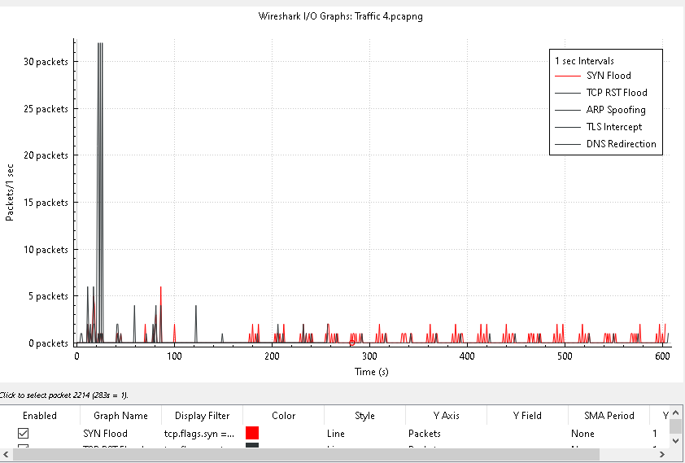
3- Determine how many distinct attacks took place with full time series analysis?
First Burst (0-20 seconds):
- Multiple Peaks: High packet rates (30+ packets per second) observed, indicating an intensive attack sequence.
- Identified Attacks:
  - ARP Spoofing: The attacker is sending spoofed ARP replies to redirect traffic.
arp.dst.proto_ipv4 == 10.10.0.1

  - TLS Intercept: The attacker responds with a forged TLS handshake, acting as a Man-in-the-Middle (MitM).
tls.handshake.type == 2
  - TCP RST Flood: Numerous Reset (RST) packets are injected to disrupt active connections.
tcp.flags.reset == 1
Second Period (20s–600s):
- Sustained Attack Pattern: The TCP RST Flood continues intermittently.
- SYN Flood: A noticeable pattern of SYN packets without completion of the TCP handshake is observed after ~40 seconds. These spikes reoccur periodically, indicating DoS (Denial of Service) attempts.
Analysis: The second phase suggests that while the ARP spoofing and TLS interception may have been resolved the attacker is still disrupting traffic with TCP RST Floods and SYN Floods, both of which aim to cause service disruption.

ARP Spoofing + TLS Intercept (MitM attack)
TCP Reset Flood (DoS attack)
SYN Flood (DoS attempt)

4- Identify all information related to the attackers and the victims?
IP Address of Victim: 10.10.0.33
Main Attacker (TLS Handshake Spoofing):
- IP Address: 2.16.119.157
- MAC Address: de:d7:f0:66:cf:6d (spoofed gateway)
- Attack: This attacker responds with spoofed TLS ServerHello messages, acting as a MitM and inserting malicious certificates during the TLS handshake.
Fake DNS or TLS Server (Secondary Attacker):
- IP Address: 2.18.105.186
- Role: Likely responsible for redirecting DNS traffic or sending a forged TLS handshake.
Spoofed Gateway (ARP Spoofing):
- IP Address: 10.10.0.1
- MAC Address: Associated with the attacker sending ARP replies, redirecting traffic through itself.
Additional Suspicious IPs:
These IPs may have participated in DNS or TLS redirection attacks:
- 142.250.179.131, 185.65.113.17, 194.87.236.205
- These addresses could resemble legitimate servers (e.g., Google, etc.), but they are likely forged in the attack, possibly involved in malicious redirection.

5-Describe the attack techniques and attempts used in details?
The attacker used ARP Spoofing to redirect the victim’s traffic by associating their MAC address with the gateway IP (10.10.0.1), enabling traffic interception. Through TLS Interception, the attacker responded to TLS handshakes with forged certificates, acting as a Man-in-the-Middle to decrypt or alter secure communications. A TCP Reset Flood was carried out by injecting a high volume of forged TCP RST packets, forcefully terminating ongoing connections. Additionally, a SYN Flood attack overwhelmed the server with numerous incomplete handshake requests, causing service disruption due to resource exhaustion.

6-Identify measures of prevention and mitigation of the identified attacks:
ARP Spoofing:
Enable Dynamic ARP Inspection (DAI) on switches.
2. TLS Interception (MitM):
Use certificate pinning to detect fake TLS certificates.
3. TCP Reset Flood:
Apply firewall rules to block unsolicited RST packets.
4. SYN Flood:
Enable SYN cookies on servers to protect against half-open connections.

